WEBSITE DOCUMENTATION
ProSport Gear

1.(a)MAIN OBJECTIVE:
-To provide customers with an easy and convenient online platform to view, choose, and purchase sportwear and equipment for different sports.
GOALS:
(1) To provide customers with product information so that they can see prices, types of product and different descriptions so that they make better choices before buying.
(2) To allow customers from different locations to access this website and not limit the business to just one area.
(3) Increase sales by allowing customers to purchase goods online anytime, which helps the business to make money.
b(i)THE TARGET AUDIENCE
-It will include teenagers, youth and adults who are more into sports and physical activities.
(ii)DEMOGRAPHIC: This website will offer a variety of sportwear and equipment that is suitable for all genders and certain age range, ensuring that everyone can find products that meet their needs and preferences.
GENDER:
-Men
-Female
AGE RANGE:
14 to 19yrs – Teens
20 to 30yrs – Youth
Above 30yrs – Adults

(iii)TECHNICAL APITUDE: Looking at the target audience the technical amplitude of my website will differ across the age groups that have been named. Teenagers are more skilled and advanced in using digital technologies, while the youth and adults have basic to moderate skills. As a result, the design for the website will be simple, user-friendly, and easy to navigate.
2.INFORMATION DESIGN AND TAXONOMY

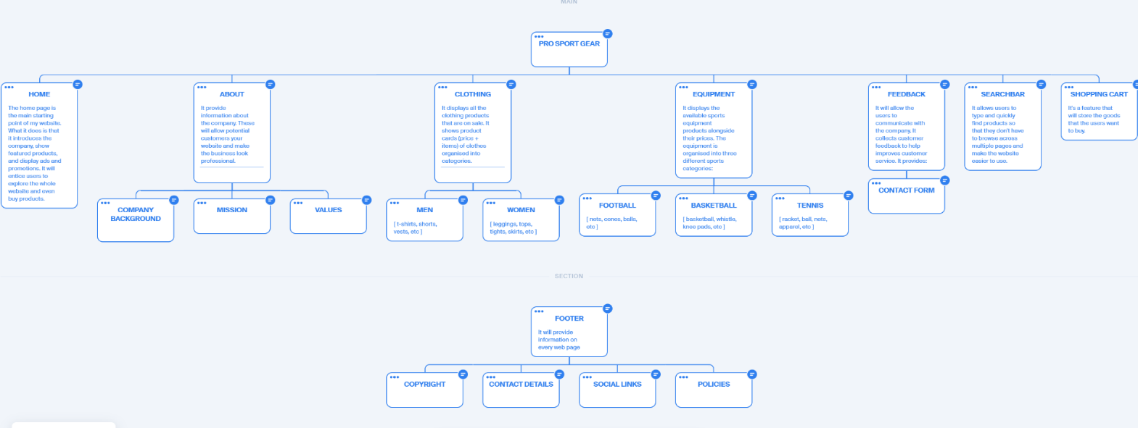

3.TECHNICAL BRIEF
(a)HTML5- I will use it to build the structure of my website. How I will use it:
*<header> - For the navigation bar.
*<nav> - To create the menu (Home, About, Clothing, Equipment)
*<section> - For various parts of my web pages (products, ads)
*<footer> - For contact, policies, social and navigation links.
*<article> - For product cards.
(b)CSS3- I will use it on multiple occasions to style and layout the appearance of my web pages.
(c)BOOTSTRAP- It will make my website responsive across multiple different devices and browsers. For example, dropdown for Clothing and Equipment.
(d)JAVASCRIPT- It will allow a sense of interactivity to elements such as dropdown menus, buttons, and contact forms with the users of my site.
(e)FONT AWESOME (Icons)- I will use it to professionally enhance the visual appeal and usability of my website.
(f)MEDIA INTEGRATION (Images and Videos)- I will use it to add visual content to make my website more intriguing and engaging for the users.
PAGE TEMPLATE
(i)LOW FEDILITY
HOMEPAGE
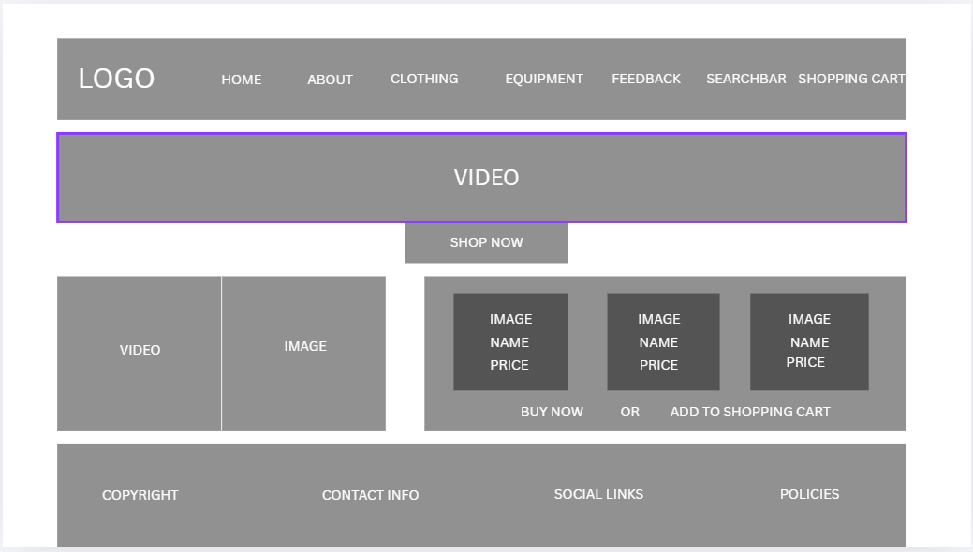
ABOUT
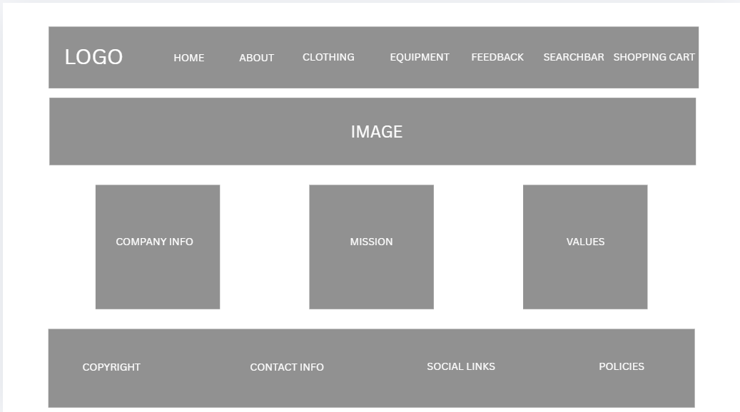
CLOTHING
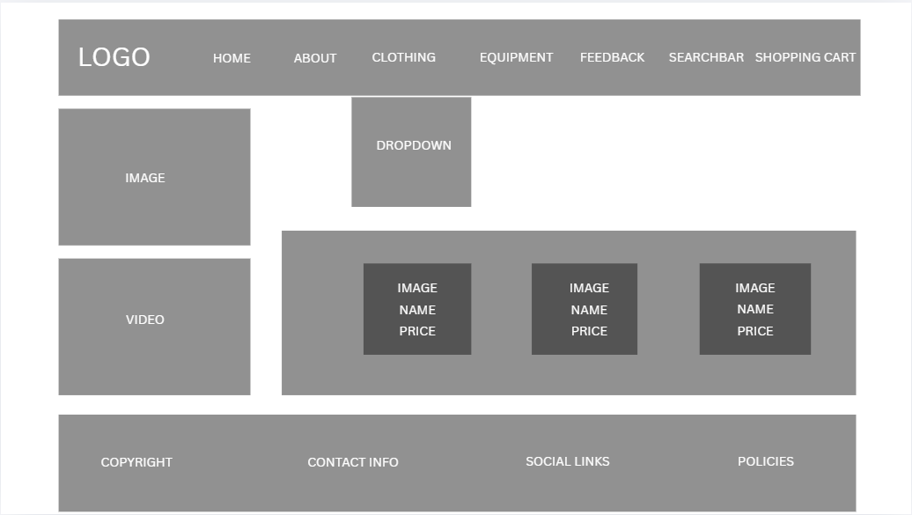
EQUIPMENT
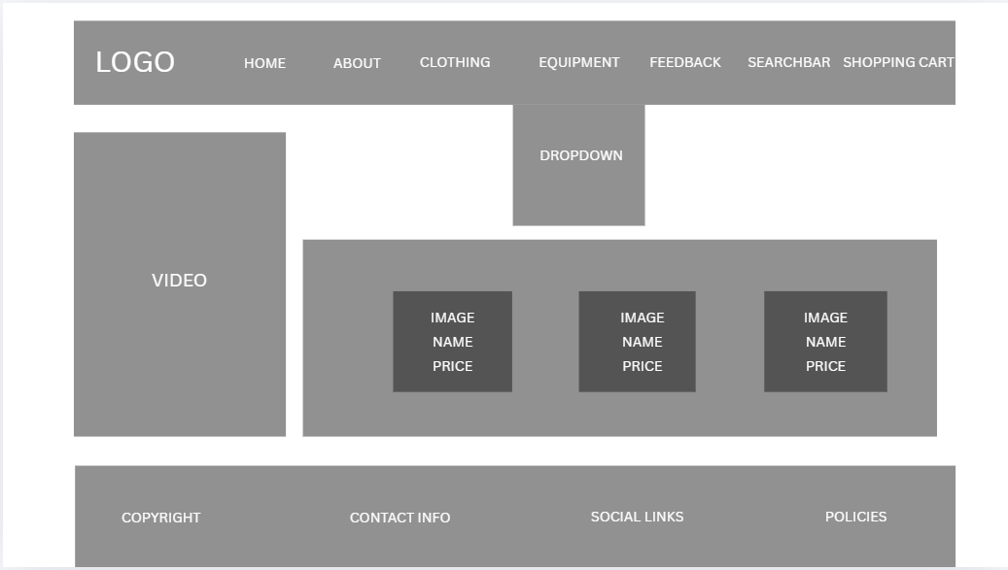

FEEDBACK
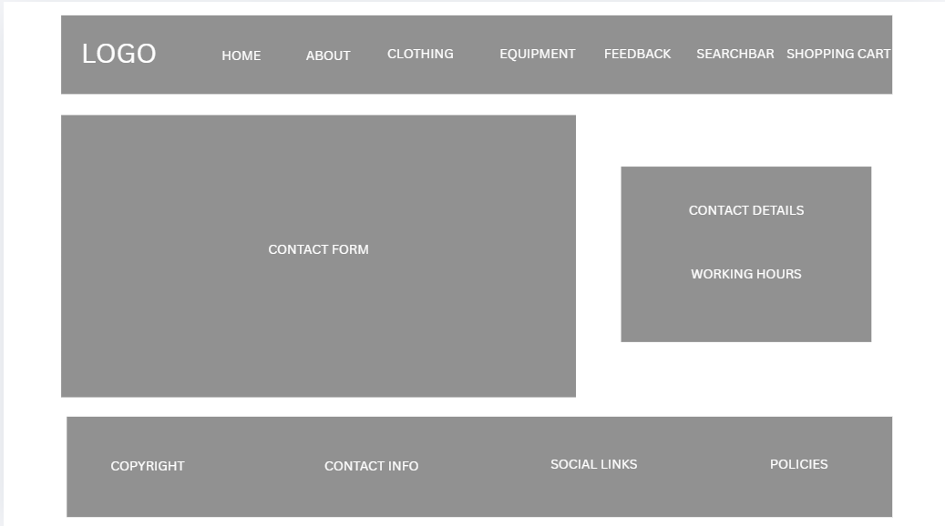
(ii)HIGH FEDILITY
